HIS Patient Extract
Installing the Required Desktop Components

Before you can run the new HIS Patient Extract in the CAS, your workstation must have the Microsoft .Net Framework 3.5 SP1 and the Microsoft XPS Document Writer installed. Please follow the instructions below to check for these components and to install them if needed.

- Click Start > Partners Applications > HISEXTRACT-CAS Installer.

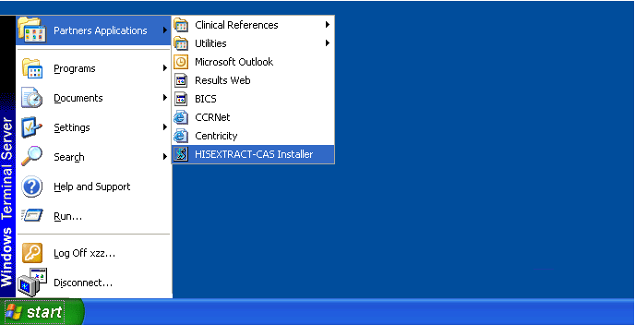

- Click OK on the installation message.

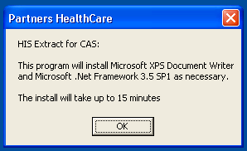

The installer checks to see if the components are installed and installs them if needed.

Important: The installation runs automatically and may take up to 15 minutes. Please allow the process to run without interruption until you see the message indicating that the desktop components have been installed.

- If Microsoft .Net Framework 3.5 SP1 is not yet installed, you will see the following message as the installation takes place.

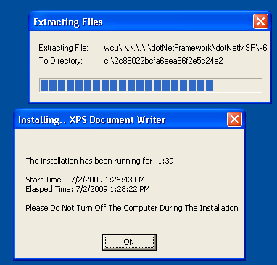

- If the Microsoft XPS Document Writer is not yet installed, you will see the following message as the installation takes place.

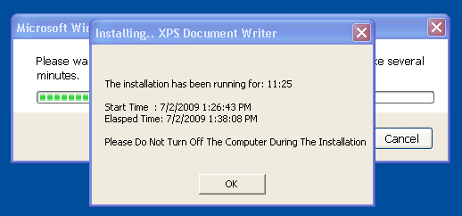

- When the installation is complete (or if no installation was needed), you will see the following message. Click OK.

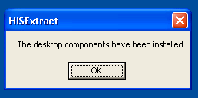

You can now access the HIS Patient Extract from the CAS Results Report Mgmt tab. If not already selected, select the patient. If not already selected, select HIS Patient Extract from the drop-down list. Click Launch HIS Extract.

